Help us to raise awareness of congenital heart disease (CHD) – Northern Ireland’s most common birth defect.

Heart kids from across Northern Ireland
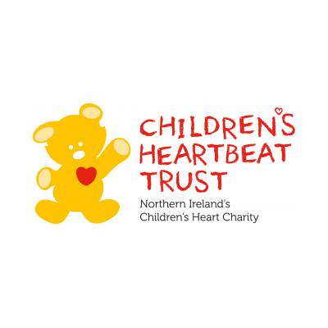
call on everyone to wear something
RED
on
Rock Red Friday
which we are celebrating on
Friday 15th February 2019.

Please send in a
£1 donation on
Friday 15th February
and support this very important cause
Thank you

