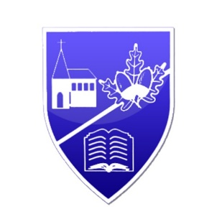
Chapel Road Primary School
Knockdara Park
Derry
BT47 2BD
Telephone: 028 71 341419
E-mail: info@chapelroadps.derry.ni.sch.uk
Website: www.chapelroadps.co.uk
Principal: Mrs C. Barrett

Dear Parents/Carers,

The children will be attending the Grove Theatre Pantomime “Jack and the Beanstalk” in St Columb’s Hall on Friday 12th December 2025.

Children will come to school at the normal time and be collected by bus to go to St Columb’s Hall at 9.30 am. Children will return to school at approximately 12.45pm and have dinner/packed lunch when they return. The cost of the trip is £5 per child.

This is a very exciting opportunity for the children to enjoy.

Kind Regards
Mrs Barrett

-----------------------------------------------------------------------------------------------------

I give permission for ____________________________ to attend “Jack and the Beanstalk” in St Columb’s Hall on Friday 12th December 2025.

Signed ________________________ (Parent/Guardian)

