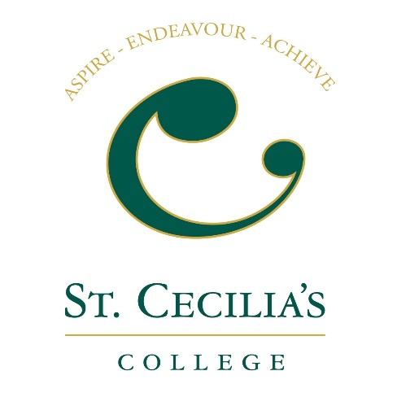
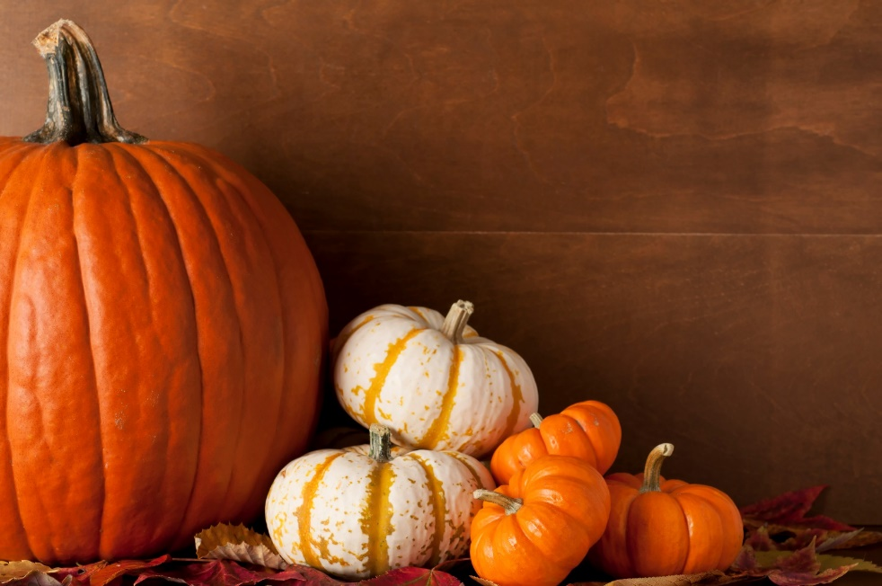
Name:
School:

Description of Pumpkin design:

Parent/ Guardian name:
Parent / Guardian Tel No:

Dear P6 & 7 pupils,

St Cecilia’s College would like to invite you to enter a HALLOWEEN PUMPKIN design competition.
Derry is renowned as the Halloween capital in Europe and as such the girls of St Cecilia’s College for the last few years have become very creative in their Pumpkin designs.
This year we are hosting a city-wide competition for all Primary 6 & 7 pupils.
You can either on your own or with the help from your family design and create a Halloween pumpkin.
You can carve it, paint it, collage or accessorise it to make your design.
All entries should be left at the college by Tuesday 24th October at 12 noon with the label attached.
All entries will be posted on social media and on display in the school foyer. All prize winners will be contacted on Thursday 26thOctober and invited to the college to collect their prize on Friday 27th October.
We wish you all the best and look forward to seeing your spooky and creative pumpkins!
St Cecilia’s College Transition Team

*Please see all information and guidance attached*

