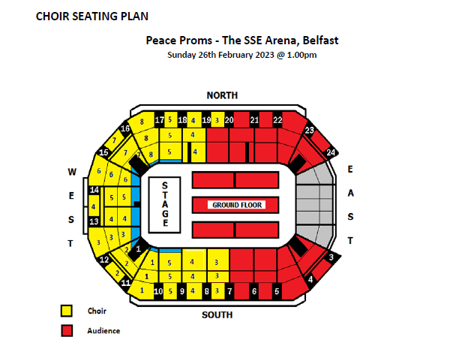
Chapel Road PS

This is the choir seating plan. We will be in the yellow section, in the West, rows 3 door 12.
I think if you sit on the ground floor near the south side or the North section around 21 or 22 you would probably see best as the arena is curved.

