

**December Newsletter 2021**

**Chapel Road Community Playgroup**

**Dear Parents/Guardians,**

Our topic this month is ‘Christmas’. We will be busy learning about the Christmas Story and singing festive songs. This year we are continuing to look forward to sharing a Christmas performance with you but in a different format so the staff and the children are busy preparing this as a special treat for you. To facilitate this, we require all our children to wear a **Christmas Jumper or Non Uniform** on **Friday 10th December**.   We will then keep you informed via Facebook of our surprise.



**COVID UPDATE**

Unfortunately, similar to other schools and the local community, there has been a rise in COVID cases. There is no doubt that the virus is more easily spread and can go undetected for a few/number of days which means more people are becoming infected. We send our good wishes to anyone who is sick or unwell. Please help us to protect everyone by observing COVID advice and guidelines.

Remain vigilant for signs and symptoms of COVID-19. Do not send your child to school if they have COVID symptoms such as:

• a high temperature

• a new continuous cough

• loss of or change to their sense of taste or smell

We will contact you if your child becomes sick during the day.

**If your child has COVID-19 symptoms:**

Book your child a PCR test as soon as possible. He/she should isolate until you get the result.

If it is negative he/she can carry on as normal and return to school as long as they are well (no fever for 48 hours).

If it is positive he/she should isolate for 10 days.

You will receive further information by text message and a contact tracing call from the PHA.

You should advise us that your child has tested positive.

Please refer to information sheet for parents/carers sent out last week.

**Dates to Remember**

The children can put the uniforms away until January 2021 and come to school wearing anything festive from the 13th December until the end of term.

**Fri 3rd DEC**

Santa Mile

**FRI 10th DEC**

Santa Visit

**MON 13th DEC**

Christmas Jumper Day

**FRI 17th DEC**

Christmas Party

**WED 22nd DEC**

Pre-school finishes at **11:30am**

**Christmas Jumpers 13th – 22nd December**

The children can put the uniforms away until January 2022 and come to school wearing Christmas jumpers/hairbands/hats/tinsel etc from **Monday** **13th December.** As always this is optional-some children/parents prefer the routine of the school uniform. There should be no pressure on anyone but the option is there if you wish.

**Adverse Weather/ Snow Arrangements**

Luckily, we are only talking about a very small number of adverse weather days when conditions may cause us an issue.

In the event of adverse weather conditions, the most important factor is the *Health & Safety* of every member of our school community. To ensure you do not feel under pressure or put anyone in a situation where children or adults are at risk we would encourage you to carefully assess the weather conditions before making the journey to pre-school. We understand that a large number of families including staff live in areas where there are steep hills and untreated roads. We do not want anyone to worry about the journey to school. We also understand that parents and guardians have the added pressure of needing to get to work on time. Unfortunately, we cannot predict or change bad weather but we can offer solutions to help us have a more pleasant experience.

**Please note the following:**

As far as is possible we will always try to open the pre-school, however, on the rare occasion where it is deemed too dangerous, a message will be sent through the website and on Facebook at the earliest opportunity.

In the event of adverse weather, there is no immediate rush required to get to school.

Just contact the Playgroup to let us know.

**(Telephone: 028 71 318838)**

If you can avoid driving up the hill to the school, please do so as it can be very slippery, especially around school time when traffic is going in both directions. A later arrival will also mean you will miss some of the congestion. A number of parents used the entrance down at Shepherd’s Glen last year and they found this an easier route.



**Birthday**

☺ Happy Birthday to you ☺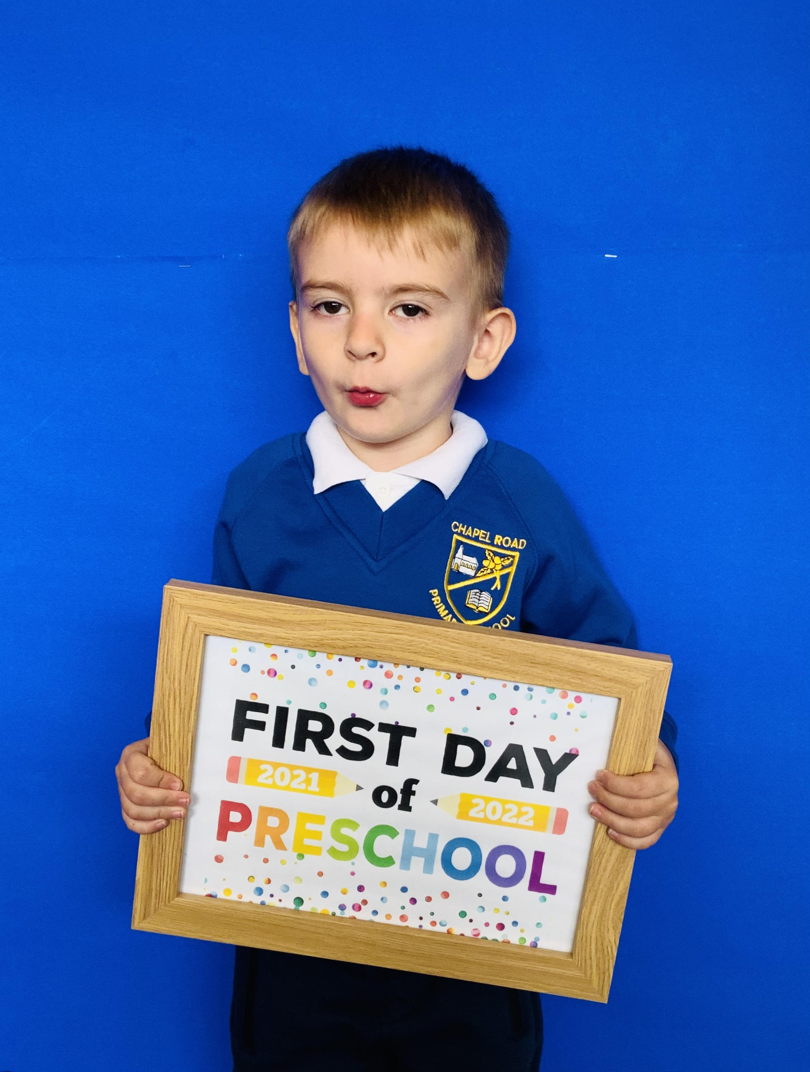

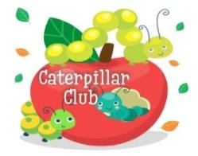

**Caterpillar Club**

Last day for Caterpillar Club this

term is **Friday 17th December 2021**.

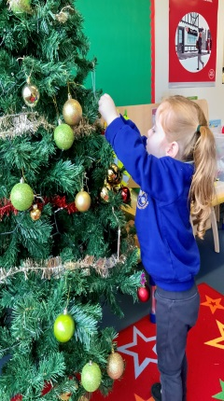

**Important Note**

Chapel Road Community Playgroup is a voluntary pre-school setting that falls under the umbrella care of Social Service and the Department of Education. A Social Services inspection is due in January 2022. During this time you may receive an email from Social Services seeking your feedback. We could encourage you to respond and thank you in advance. Miss Blee.

**Pre-School/Primary 1 Applications 2022**

Applications for admission to Primary 1 will open on Monday 10th January 2022 at 12 noon via the Education Authority online portal. The portal will close on Friday 28th January 2022 at 12 noon.



The playgroup staff

would like to thank you

for your support during

this term.

We wish you all a very

Merry Christmas

and a Happy New Year!