CALLING ALL READING BOOKS
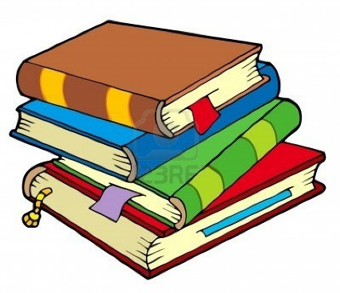
We would Kindly ask that all children have a look at home for any Reading books that they may have had from the school during or before Lockdown.

They may be Library books, Oxford Reaading Tree Books, or Novels.
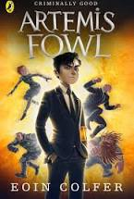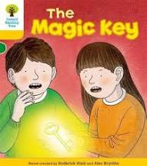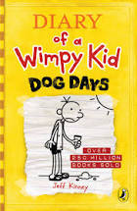
We would ask that you return them to your child’s teacher.
Thank You!

