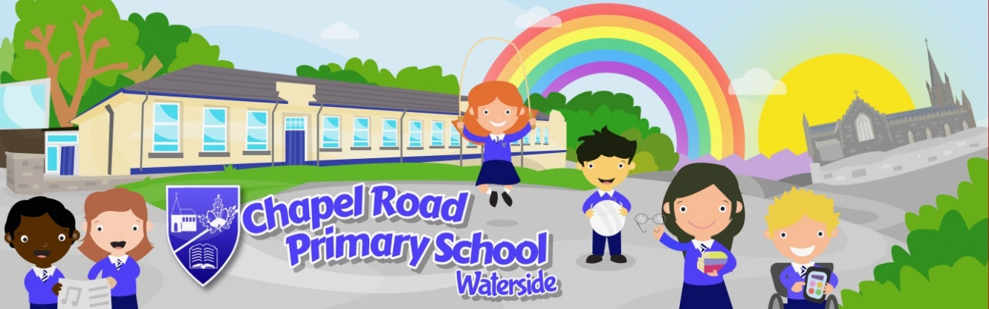

Friday 26th February 2021
Dear parents/guardians
We received a letter from the Minister for Education so I can now provide official confirmation of the arrangements from the 8th March 2021.
REMINDER –all pupils will have Wednesday 17th March off for St. Patrick’s Day celebration.
ATTENDANCE ARRANGEMENTS ARE AS FOLLOWS:
PRIMARY 1, PRIMARY 2 AND PRIMARY 3 PUPILS
- Pupils in P1, P2 and P3 will attend school from the 8th until 19th March.
- Pupils will be expected to wear full school uniform.
- Daily routines and hygiene practices will continue as for Term 1.
- Pupils can arrive from 8.45am where they will be met by staff.
- Learning begins at 9.00am.
- Remote learning will resume for pupils in P1, P2 and P3 on Monday 22nd March until 12 noon on Friday 2nd April.
- Easter holidays begin 2nd April at 12 noon until Friday 9th April.
- Pupils in P1, P2 and P3 return to school after the Easter holidays on Monday 12th April.

PRIMARY 4, PRIMARY 5, PRIMARY 6 AND PRIMARY 7 PUPILS
- P4, P5, P6 and P7 pupils will continue with remote learning at home until further notice.
- Easter holidays begin 2nd April at 12 noon until Friday 9th April.
- Pupils in P4, P5, P6 and P7 return to remote learning on Monday 12th April.
- It is expected that a phased return to school for these classes will be shared by the Minister for Education in due course.

SUPERVISED LEARNING FOR KW&VC
- Provision for children of key workers and those deemed vulnerable will continue from the 8th March.
- Daily routines and hygiene practices will continue as before.
- Easter holidays begin 2nd April at 12 noon until Friday 9th April.
- Provision for children of key workers and those deemed vulnerable will continue after the Easter holidays on Monday 12th April.
- Pupils attending must wear full school uniform.
- Pupils need to bring a healthy morning break.
- Pupils will need to bring lunch including a bottle of water. (see other information on school meals arrangements)

OTHER IMPORTANT INFORMATION
- Normal home times will apply.
- Contact the office via telephone or info account if you need to change collection times.
- Lollipop service will resume.
- Face mask/covering to be worn at the school gate unless exempt.
- Please do not congregate at the school gates. Wait in the car until your child has been brought out to the gate.
- Maintain social distancing at all times.
- Access to the school building is by appointment only so please give us a call if you need assistance.

SCHOOL MEALS PROVISION-Please read this information carefully
Pupils in P1, P2 and P3 who are in receipt of Free School Meals will be served a free lunch whilst in school from the 8th March.
Pupils in P1, P2 and P3 who pay for their school meal have the option of bringing a packed lunch or paying for a lunch. Please try to do this on a Monday for the week.

Pupils in P4, P5, P6 and P7 who are in receipt of Free School Meals and are attending supervised learning will not be served a free lunch in school due to payment already being sent to parents via bank transfer. They can however, order a lunch and pay for it. Please try to do this on a Monday for the week.
Pupils may also decide to continue to bring a packed lunch.

I hope this information is helpful and allows you to prepare for the weeks ahead. It is our hope that we will all be back together in school as soon as possible. As always, if you have any questions please give us a call or email us.
Have a lovely weekend
Take care
Mrs Bacheta

