

**Save the Date!**

**Chapel Road’s**

**Christmas Fair**

**Thursday 15th November 2018**

**@ 6.00pm** 

**Not to be missed.**

**Fun and games planned to suit everyone.**

**Make this your special family event this Christmas.**





Dear Chapel Road boys, girls, families and friends,

We are delighted to invite you to come along and join us on Thursday 15th November as we host our Christmas Fair.

We have put a lot of effort into planning what we hope will be an enjoyable night for everyone. We especially want all our fantastic boys and girls to have fun and make fond Christmas memories with their families and friends. We are excited to spend an evening with you and the children where it is all about fun and good cheer.

Please make a special effort to come along and support us on the night-you will love it!!



A special thanks to all the staff who are already busy with planning and preparations.

**CHRISTMAS FAIR FUN AND GAMES**

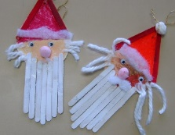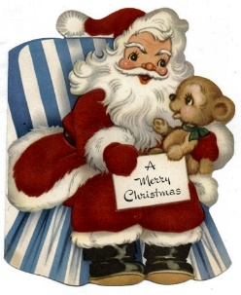

**SANTA’S GROTTO**

**SPOT THE BALL**



**CANDY CANE LOTTO**



**LUCKY**

**DIP**





**SPOT THE**

**BALL**

**TOMBOLA**



**DROP THE**

**COIN**

**PLAY YOUR CARDS RIGHT**

**REFRESHMENTS**

**INCLUDING HOT CHOCOLATE/TUCK SHOP**





**CRAFT STALLS**

**BOOK STALL**

